#TRAFFIC LIGHT

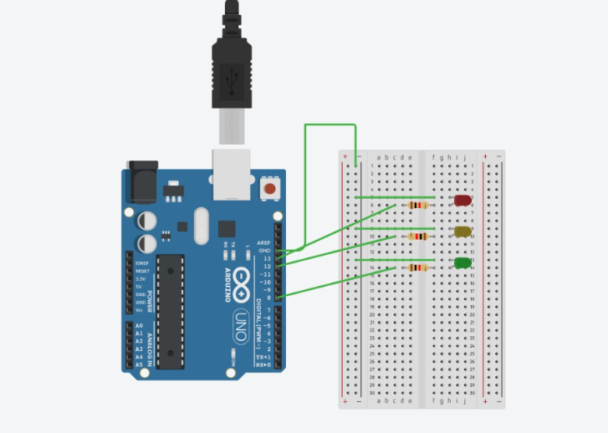
int led1=13;
int led2=12;
int led3=8;

void setup()
{
pinMode(led1,OUTPUT);
pinMode(led2,OUTPUT);
pinMode(led3,OUTPUT);

}

void loop()
{
digitalWrite(led1, HIGH);
delay(1000); // Wait for 1000 millisecond(s)
digitalWrite(led1, LOW);
delay(1000); // Wait for 1000 millisecond(s)

digitalWrite(led2, HIGH);
delay(1000); // Wait for 1000 millisecond(s)
digitalWrite(led2, LOW);
delay(1000); // Wait for 1000 millisecond(s)

digitalWrite(led3, HIGH);
delay(1000); // Wait for 1000 millisecond(s)
digitalWrite(led3, LOW);
delay(1000); // Wait for 1000 millisecond(s)
}
Conclusion : The Arduino traffic light experiment successfully demonstrated how LEDs can be controlled using timed code to mimic real traffic signals. By programming delays and sequences for red, yellow, and green lights, the project showed how Arduino can manage automated signaling systems, similar to those used in real-world traffic control.

